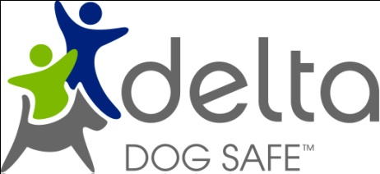

Teacher Evaluation

Thank you for inviting Delta Dog Safe to your classroom.

Please take the time to help us improve the program by completing and returning this form to:

Delta Dog Safe Coordinator

Email: [anne@deltadogsafetas.org.au](mailto:anne@deltadogsafetas.org.au)

Fax 03 6248 7661

Venue……………………………………………….. Grade………………………….. Date……………….

1. What aspects of the visit were most valuable for your students?
2. What aspects of the visit were least valuable for your students?
3. Was the presentation, language and activities appropriate for the age group?
4. Would you recommend Dog Safe to other teachers?
5. Do you have any suggestions for improvements to the program?

Any other comments: